

INT 230-Account AP (AP) Invoice
Openlink è SAP Integration
System Integration Requirements & Design

Table of Contents
1. Platform Information 4
1.1. Contacts 4
1.2. Document Library 4
1.3. Objective 5
1.4. Dependencies and Risks 5
1.5. Success Criteria 5
2. Business Requirements 5
2.1. Business Workflows or Logic 5
3. Integrations Overview 6
3.1. Integrations in Scope 7
3.2. Functional Diagram 7
3.3. Integration Details 7
3.4. Data Flow Steps 8
3.5. Additional Details 8
4. Source System 9
4.1. System Integration Component Diagram 9
4.2. Key Assumptions 9
4.3. Connectivity Details 9
4.4. Source Data Mapping & Key Transformation Rules 10
4.5. Security Considerations 10
4.6. Error Handling & Recoverability 10
5. Destination System 10
5.1. System Integration Component Diagram 10
5.2. Key Assumptions 11
5.3. Destination Data Mapping 11
5.1. Connectivity Details 11
5.2. Key Transformation Rules 11
5.3. Security Considerations 11
6. Enterprise Integration Hub 12
6.1. Integration Pattern 12
6.2. Integration Design 12
6.3. Key Assumptions 14
6.4. Connectivity Details 14
6.5. Security Considerations 14
6.6. Data Mapping and Transformation Rules 14
6.7. Error Handling & Recovery 14
6.8. Success Criteria 14
6.9. Test Data 14
7. Test Cases 14

Platform Information
To be completed and validated by the Digital Liaison.

Contacts
Business Owner(s) | Sarah, Reda
Digital Liaison (s) | Kent Madeira, Courtney Cannatti - OPENLINK  Brad Kyer, Chad Riccio - Openlink
Digital Technical Architect | Rajat Modi
Source SME or Vendor | Brad Kyer – Openlink
Destination SME or Vendor | Kent Madeira – OPENLINK
SAP IT Ddirector | Abdul Raphe – SAP
SAP SME | Vamsi Udhya - SAP
Openlink SME | Sandeep Chinta

Document Library
Document | Link
Requirements and Design Documentation Root Folder | OpenLink and SAP
Openlink Functional Design | Enable seamless transfer of invoice documents and associated metadata from Openlink to SAP S/4HANA for financial posting and Vendor Invoice tracking.  Source System: Openlink  Invoice Types: Vendor Invoices  Target System: S/4 HANA (FI-AP Module)  Transaction Type: Vendor Invoice  Integration Flow Table:
  Step | Description
  1. Invoice Creation in Openlink | AP Invoice is created in Openlink
  2. Invoice Approval | Operations Manager reviews and approves the invoice
  3. Invoice Export | OPENLINK exports invoice data in XML or JSON format.
  4.Middleware Transformation | EIH transforms OPENLINK data into SAP-compatible API payload.
  5. SAP Posting | Invoice is posted in SAP FI-AP with linkage to Vendor.
  6. Reconciliation & Error Handling | Errors logged and routed to finance team; successful postings updated back to OPENLINK.

Objective
End-to-End Digitalization of Invoice Processing Lifecycle
- From invoice receipt in OPENLINK to financial closing in SAP
- Eliminates manual data entry and reduces errors

Real-Time Visibility Across Operations and Finance
- Unified view to invoice and posting data across teams
- Enables faster decision-making and performance benchmarking
Automated Workflows and Reduced Operational Overhead
- Streamlined financial posting process with consistent data structures and audit traceability
- Exception handling for delays, fuel deviations, and contract breaches
AI-Driven Optimization
- Predictive analytics for invoice processing cycle times and spend patterns
- Machine learning models trained on OPENLINK data integrated with SAP AI Core
Scalable Cloud Architecture
- Cloud-to-cloud integration via SAP Integration Suite
- Secure, scalable, and future proof to support increasing invoice volume and additional entities

Dependencies and Risks
Key Dependencies:
- API availability and stability – OpenText must expose stable and well-documented integration services
- Data model alignment – Mapping OpenText invoice metadata and line-item coding to SAP financial structures
- SSO and OAuth between OpenText and SAP for secure and seamless system access
- Process synchronization – Timely transfer of invoice data from OpenText to SAP to support month-end close and financial reporting

- Upstream Dependencies:

- Downstream Dependencies:

- Known Risks:
- Data inconsistency - Mismatches between OPENLINK invoice data and SAP financial postings. Risk of duplicate or missing transactions
- Latency and Performance - Delays in data sync can affect real-time reporting and automation. Especially critical for closing and invoicing.
- Integration failures - API changes or outages in OPENLINK can break SAP workflows.
- Compliance and audit risks - Incomplete or incorrect charter party data can lead to audit issues. Fuel reconciliation errors may impact financial reporting.

Success Criteria
- End-to-End Process Integration
- Seamless data flows from OPENLINK planning to SAP financial closing.
- No manual intervention required for core workflows (e.g., Invoice-to-Posting).
- Business Value Realization
- Improved invoice processing accuracy and financial posting consistency.
- Reduced turnaround time for invoicing and accruals.
- Stakeholder Satisfaction
- Accounts Payable, Accounts Receivable, and Finance teams report improved processing efficiency.
- Clear ownership and accountability across integrated processes.

Business Requirements
To be completed by the Digital Liaison. State what the business needs from the integrations. Provide use case.
Business Function | Export Invoice and Journal Entries from OPENLINK to SAP
Integration Name | OPENLINK > SAP
Source System | OPENLINK
Destination System | SAP

Business Function | Import Payments\Receipts from SAP to OPENLINK
Integration Name | SAP > OPENLINK
Source System | SAP
Destination System | OPENLINK

Business Workflows or Logic
The below provides a high-level overview of the workflow the interface is designed to support:

Business Workflows:
- AP/AR Invoice, Journal Entry Posted in OPENLINK:
  - Will generate an Invoice export message and send it to SAP, triggered upon Posting in OPENLINK.
    - Posting in OPENLINK locks the Invoice, preventing further updates
- Payment\Receipt Entered in SAP:
  - Will generate OPENLINK simple Payment message and send to OPENLINK
    - This will mark the Invoice as paid and update the OPENLINK Payables\Receivables summary, along with Cash In\Out column on the Profit and Loss view

Integrations Overview

Source Integration | Overview and Description
- OPENLINK – Invoice | Export AP Invoices and Journals from OPENLINK to SAP

Destination Interface | Overview and Description
SAP | Import AP Invoices into SAP

Integrations in Scope
Source Integration | Overview and Description
AP Invoice

Integration Details
Integration 1 – OPENLINK to SAP:
Attribute | Value
Data Exchange Method | SOAP API (with SAP), REST (with EIH)
Message Format | XML & JSON
Protocol | HTTPS
Authentication | OAuth for SAP and EIH
Frequency | Frequency details are given below
Synchronous/Asynchronous | Asynchronous
Additional Details

Type of Invoice | Frequency | Trigger
Freight Invoices | Weekly or per Voyage | Upon Voyage Completion or milestone
Demurrage/Laytime | Ad hoc | Based on Voyage events
Bunker/Fuel Invoices | Monthly or per delivery | Based on fuel delivery
Port Charges & Misc | Monthly or per port call | Based on port call completion
Charter Hire Invoices | Monthly or bi-weekly | Based on Charter Agreement

Data Flow Steps
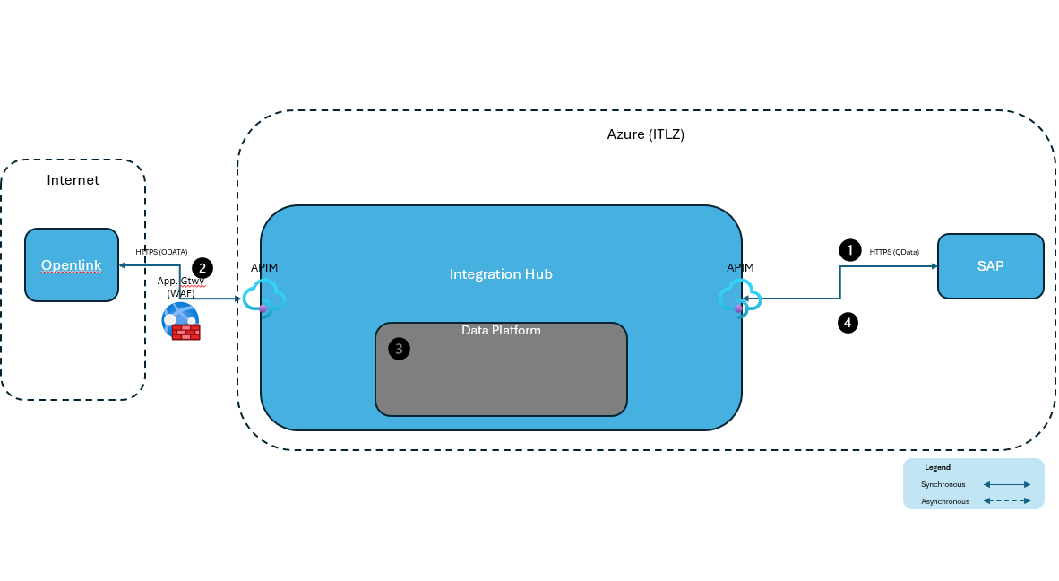
Step 1 | Openlink will push to Integration Hub on demand using HTTPS (REST API) (after successful authentication and authorization)
Step 2 | Integration Hub then pushes to SAP
Step 3 | The retrieved records from Openlink are saved to ADLS in landing zone as a file for Data Platform to process.
Step 4 | Integration Hub sends acknowledgement (SAP Response) back to Openlink Webhook

Additional Details
The purpose of this interface is to integrate OPENLINK and SAP, where AP\AR Invoices and Journals will be exported from OPENLINK to SAP and related Cash Disbursements are exported from SAP back to OPENLINK.

Source System
This section details the criteria, frequency, volume, and key assumptions related to the source system. It provides information on how data is sourced, processed, and integrated into the system. Additionally, it addresses the security measures and considerations for this integration, specifies the transformation rules applied to the data, outlines the strategies and practices implemented to protect this integration and data from security threats, describes the end points for data integration, and provides a diagram of the integration process.

System Integration Component Diagram

Key Assumptions
Any assumptions about the destination that would impact the integration: i.e., destination is not available after hours, volume, frequency, security, etc.
- The OPENLINK standard formats will be sent, any transformation or mapping logic will be done in the source system

Connectivity Details
Outbound Trigger Method: Openlink is configured to trigger outbound messages based on invoice posting business events.

Payloads
Following is a sample payload for accounts payable that Openlink will be sending to EIH.
AR Voyage: Payload
Triggers & Schedule
Requirement | Value
Trigger Criteria | Invoicing Posting from Openlink
Frequency | On Demand
Volume | Low to medium
Data Mapping & Key Transformation Rules | See Mapping Tables for Mapping
Connectivity End Point | Openlink REST API http post to Integration Hub

Source Data Mapping & Key Transformation Rules
Please refer to the Mapping document below for Transformation rules:
Mapping / Transformation | Openlink SAP Field Mapping.xlsx

Security Considerations
- OAuth 2.0 / API Key Management for OPENLINK REST APIs.
- SAP Identity Authentication Service (IAS) for secure access to SAP Cloud.
- Role-Based Access Control (RBAC) across both platforms to ensure least privilege.
- Encryption in Transit: Use HTTPS/TLS for all API calls between OPENLINK and SAP.
- Encryption at Rest: Ensure sensitive , fuel, and financial data is encrypted in both systems.
- Data Minimization: Only transfer necessary data fields to reduce exposure.

Error Handling & Recoverability

Destination System

System Integration Component Diagram
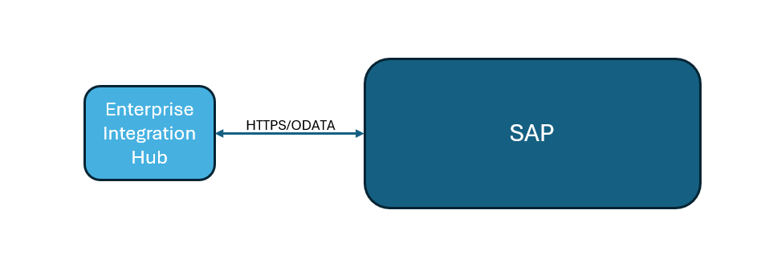

Key Assumptions
Any assumptions about the destination that would impact the integration: i.e., destination is not available after hours, volume, frequency, security, etc.
- Messages will be sent in OPENLINK-specific format, formatted as XML or JSON

Destination Data Mapping
Please refer to the Mapping document below for Transformation rules:
Mapping / Transformation | Openlink SAP Field Mapping.xlsx

Connectivity Details
Tier | System | Base URL | Port
Development | DS1 | SAPDS1APP.NEXT-DECADE.COM | 44300
QA | QS1 | SAPQA.NEXT-DECADE.COM
Production | PS1 | SAP.NEXT-DECADE.COM

Endpoint URL: https://sapds1app.next-decade.com:44300/sap/bc/srt/xip/sap/journalentrycreaterequestconfi/200/journalentrycreaterequestconfi/journalentrycreaterequestconfi
Sample Body: Following is the sample payload that is sent to SAP for AR posting
Sample_SAP_AR_Payload.xml
Following APIs are identified on SAP System:
AR Invoice: JournalEntryCreateRequestConfirmation_In
Purpose: Post financial documents including customer invoices.
Following is the format specifications and example XML messages SAP Return Status\Document Ref. (invoiceStatus) messages. The message is sent back to Openlink as a

Key Transformation Rules
List source to destination data mapping and transformation details. May reference the mapping and transformation document on SharePoint. (If any)
Sample payload:

Following is the format specification for Invoice status SAP return status

Security Considerations
API Token Authentication:
- EIH to communicate with SAP using OAuth Token
- SAP Identity Authentication Service (IAS) for secure access to SAP Cloud.
- Role-Based Access Control (RBAC) across both platforms to ensure least privilege.
- Encryption in Transit: Use HTTPS/TLS for all API calls between openlink and SAP.
- Encryption at Rest: Ensure sensitive voyage, fuel, and financial data is encrypted in both systems.
Data Minimization: Only transfer necessary data fields to reduce exposure

Enterprise Integration Hub
Enterprise Integration Hub: This section discusses the integration hub and its components. Additionally, it presents a high-level design diagram of the system, details the components involved in Azure integration, and includes information on data transformation, security and connectivity.

Integration Pattern
The integration pattern that will be used for this integration is shown here, along with key details.
Link to Pattern: Integration Hub Wiki - Overview
The integration pattern that will be used for this integration is shown here, along with key details.
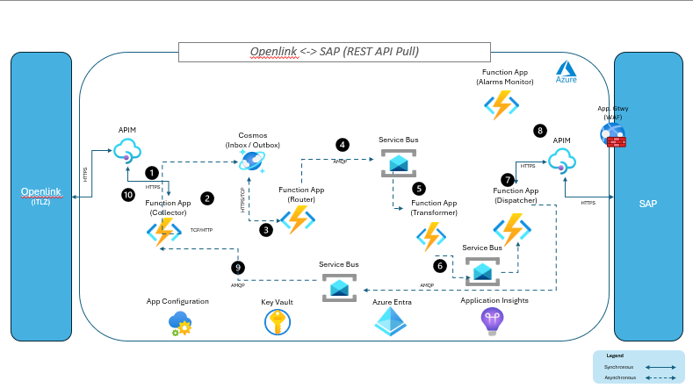

The key components involved in the above integration are as follows:
- Integration Hub Collector App: A function named “openlink-accountspayable-sap-collect” receives the API request via HTTP Trigger, validates the request then it unwraps the payload, hydrates the integration event with metadata and persists that into the Cosmos (Inbox). Refer to the following Collector Wiki link for more details: Collector App - Overview A sample Json of the persisted payload is shown below
{
{
"AP" : [ {
"CompanyCode" : "1700",
"DocumentEntryType" : "NG Purchase AP",
"DocumentDate" : "2025-08-21",
"PostingDate" : "2025-08-31",
"CalculationDueDate" : "2025-10-27",
"DocumentHeaderText" : "NG Purchase AP",
"TransactionCurrency" : "USD",
"ReferenceDocumentNumber" : "N/A",
"Businesspartnernumber" : "1000408",
"InvoiceAmount" : "-900000.00",
"ReferenceKey1InternalforDocumentHeader" : "22627",
"LineItems" : [ {
"ItemNumber" : "01",
"CreditDebit" : "Credit",
"AmountInTransactionCurrency" : "-900000.00",
"AssignmentNumber" : "22627",
"CostCenter" : "1700000",
"ItemText" : "NG Purchase AP",
"GLAccount" : "50001003"
}]
}],
"WebhookURL" : "https://azwopenlnkdsc01.next-decade.com/Openlink-Interface/Openlink/NextSys/InboundRequest"
}

Integration Hub Router App: Processes the in-boxed event and hydrates it with the routing-slip information and persists that into outbox, which is again processed by the router and dispatched to the first topic “openlink-accountspayable-sap-transform” in the route. Additional details of the Router App are provided in the ND Integration Hub Wiki Router App - Overview
Following is the routing slip for this integration:
{
"id": "openlink-accountspayable",
"source": "openlink",
"type": "accountspayable",
"routingSlip": {
"routes": [
{
"destination": "sap",
"topics": [
"openlink-accountspayable-sap-transform",
"openlink-accountspayable-sap-dispatch",
"sap-accountspayable-openlink-collect"
]
}
]
}
},
- Integration Hub Transformer App: The transformer app subscribes to the “openlink-accountspayable-sap-transform” topic where the event is published by the router and after receiving the message, unwraps the payload and executes the transformation logic (Refer to the data mapping source and target message examples for data structures and field map for transformation logic). The transformed payload is sent to the next topic on the route. Any error during transformation would be a non-retriable error and should be logged in detail (unless it’s connected to an external API and if there is a transient error, then it should be retriable via Integration Hub Monitor App). Additional information about the Dispatcher App are on the ND Integrated Hub Wiki Transformer App - Overview

- Integration Hub Dispatcher App: The dispatcher app subscribes to the “openlink-accountspayable-sap-dispatch” topic where the event is published by the transformer and after receiving the message, unwraps the payload and executes the SOAP/REST query against the configured Oepnlink API endpoint. Transient errors are retried and should be escalated to Retry topic where the Integration Hub Monitor App retries for the configured number of times after which the error is escalated and logged into Application Insights. Refer to the target message example for data payload to be sent to Openlink. Additional information about the Dispatcher App are on the ND Integrated Hub Wiki Dispatcher App - Overview.

Data Lake: Once the data is received to dispatcher it saves the payload to data lake gen 2 raw storage. The file uploaded will be time-stamped by its fetch date. e.g. accountsreceivableyyyymmddhhmmss.json. Complete path to the storage would be for e.g.“/{source}/{integrationtype}/incremental/{integrationtype} _20251017/integrationtype20251017060009.json”. The raw payload is also saved in blob storage using our convention. Additional information about the Data lake integration are on the ND Integrated Hub Wiki Datalake Integration - Overview.

- Integration Hub Collector App: A function named “sap-accountspayable-openlink-collect” receives the SAP response payload in the service bus topic from the dispatcher, validates the request then it unwraps the payload, and send back as a response to Openlink. Refer to the following Collector Wiki link for more details: Collector App - Overview.

A sample SOAP xml is shown below:
<soapenv:Envelope
xmlns:soapenv="http://schemas.xmlsoap.org/soap/envelope/"
xmlns:sfin="http://sap.com/xi/SAPSCORE/SFIN">
<soapenv:Header/>
<soapenv:Body>
<sfin:JournalEntryBulkCreateRequest>
<MessageHeader>
<ID>Openlink-2025-11-24</ID>
<!-- Current Date-->
<CreationDateTime>2025-10-15T12:00:00.1234567Z</CreationDateTime>
</MessageHeader>
<!-- One to Many -->
<JournalEntryCreateRequest>
<MessageHeader>
<ID>Openlink-2025-11-24</ID>
<!-- ReferenceKey1InternalforDocumentHeader In Openlink-->
<CreationDateTime>2025-10-15T12:00:00.1234567Z</CreationDateTime>
</MessageHeader>
<JournalEntry>
<OriginalReferenceDocumentType>BKPFF</OriginalReferenceDocumentType>
<!-- Constant value-->
<BusinessTransactionType>RFBU</BusinessTransactionType>
<!-- Constant value-->
<AccountingDocumentType>YP</AccountingDocumentType>
<!-- Constant value AS YP -->
<DocumentReferenceID>INV-2025-000001</DocumentReferenceID>
<!-- Reference Document Number in Openlink sheet -->
<DocumentHeaderText>Vendor invoice Nov 2025</DocumentHeaderText>
<!-- Document Header Textt in Openlink sheet-->
<CreatedByUser>RFC_OPLINK</CreatedByUser>
<CompanyCode>1500</CompanyCode>
<!-- CompanyCode in Openlink sheet-->
<DocumentDate>2025-11-18</DocumentDate>
<!-- DocumentDate in Openlink sheet-->
<PostingDate>2025-08-21</PostingDate>
<!-- PostingDate in Openlink sheet-->
<Reference1InDocumentHeader>REFKEY12345678901234</Reference1InDocumentHeader>
<!-- ReferenceKey1InternalforDocumentHeader in Openlink sheet -->
<CashDiscountTerms>
<DueCalculationBaseDate></DueCalculationBaseDate>
<!-- Calculation Due Date in Openlink sheet -->
</CashDiscountTerms>
<CreditorItem>
<AssignmentReference>ASN000000000000002</AssignmentReference>
<!-- AssignmentNumber in Openlink sheet -->
<ReferenceDocumentItem>01</ReferenceDocumentItem>
<!--Constant value to 01-->
<Creditor>1000932</Creditor>
<!-- Businesspartnernumber in Openlinke sheet-->
<AmountInTransactionCurrency currencyCode="USD">-1500.50</AmountInTransactionCurrency>
<!-- Transaction Currency / InovoiceAmount in Openlink sheet-->
<DebitCreditCode>H</DebitCreditCode>
<!-- Constant value As H -->
</CreditorItem>
</JournalEntry>
<!-- Item is an Array all item should be same and Only transforamtion on Amount -->
<Item>
<AssignmentReference>ASN000000000000001</AssignmentReference>
<!--AssignmentNumber in Openlink sheet -->
<ReferenceDocumentItem>02</ReferenceDocumentItem>
<!--Increment amd start with 02-->
<GLAccount>65100000</GLAccount>
<!-- GL Account in Openlink sheet-->
<!-- AmountInTransactionCurrency reverse the value what you getting from Openlink postive value to neg and neg value to postive -->
<AmountInTransactionCurrency currencyCode="USD">1200</AmountInTransactionCurrency>
<!-- Transaction Currency / AmountInTransactionCurrency in Openlink sheet-->
<DebitCreditCode>S</DebitCreditCode>
<!-- Constant value As S -->
<DocumentItemText>Consulting services - Project A</DocumentItemText>
<!-- ItemText in Openlink sheet-->
<AccountAssignment>
<CostCenter>1500005</CostCenter>
<!-- CostCenter in Openlink sheet-->
</AccountAssignment>
</Item>
<Item>
<AssignmentReference>ASN000000000000001</AssignmentReference>
<!--AssignmentNumber in Openlink sheet -->
<ReferenceDocumentItem>03</ReferenceDocumentItem>
<!--Increment amd start with 02-->
<GLAccount>65100000</GLAccount>
<!-- GL Account in Openlink sheet-->
<!-- AmountInTransactionCurrency reverse the value what you getting from Openlink postive value to neg and neg value to postive -->
<AmountInTransactionCurrency currencyCode="USD">1200</AmountInTransactionCurrency>
<!-- Transaction Currency / AmountInTransactionCurrency in Openlink sheet-->
<DebitCreditCode>S</DebitCreditCode>
<!-- Constant value As S -->
<DocumentItemText>Consulting services - Project A</DocumentItemText>
<!-- ItemText in Openlink sheet-->
<AccountAssignment>
<CostCenter>1500005</CostCenter>
<!-- CostCenter in Openlink sheet-->
</AccountAssignment>
</Item>
</JournalEntryCreateRequest>
</sfin:JournalEntryBulkCreateRequest>
</soapenv:Body>
</soapenv:Envelope>

Integration Design

- Frequency (Delivery Compliance to Azure)
- Key Assumptions
- Security Considerations
- Data Mapping & Transformation Rules
- Connectivity End Point
- High Level Design Diagram
- Azure Integration Components
Attribute | Value
Data Exchange Method | SOAP API
Message Format | XML
Protocol | HTTPS
Authentication | OAuth for SAP and Openlink
Frequency | Few times per day.
Synchronous/Asynchronous | Synchronous
Additional Details

Source Message Format details:
Message Name | Description | Request Format | Response Format
Invoice | Export Invoice\Journal from Openlink to SAP | XML (or JSON if preferred) | String

Target Message Format details:
Message Name | Description | Request Format | Response Format
Payment | Export Cash Disbursement from SAP to Openlink | XML | XML

Key Assumptions
- The list of API endpoints that will be covered in this integration is listed in this document
- Openlink will send REST and SAP SOAP API through API endpoints
- Integration will map the data that has been provided in the mapping document

Connectivity Details
Connectivity endpoint:
Tier | System | Base URL | Port
Development | DS1 | SAPDEV.NEXT-DECADE.COM | 44300
QA | QS1 | SAPQA.NEXT-DECADE.COM
Production | PS1 | SAP.NEXT-DECADE.COM

Security Considerations
- Openlink will authenticate using JWT Token with Enterprise Integration Hub
- Enterprise Integration Hub will Authenticate with SAP using oAuth 2.0. These connection details will be stored in Azure Key Vault.
- Appropriate ports will be open to allow secure TLS traffic flow between Openlink, Enterprise Integration Hub & SAP systems.

Data Mapping and Transformation Rules
Mapping / Transformation | Refer to the Mapping tables. Openlink SAP Field Mapping.xlsx

Error Handling & Recovery
Category | Error Scenario | Description | Handling / Recovery Strategy
Network & Connectivity | Timeout | Request takes too long to respond | Retry 3 times using monitor function before logging error in application insights with corresponding record correlation id to uniquely identify the current transaction.
Network & Connectivity | Connection Refused | System is down or unreachable | Retry 3 times using monitor function before logging error in application insights with corresponding record correlation id to uniquely identify the current transaction.
Network & Connectivity | DNS Resolution Failure | Domain Name cannot be resolved | Log error in application insights
Authentication & Authorization | 401 Unauthorized | Invalid or expired certificate / credentials | Log error in application insights
Authentication & Authorization | 403 Forbidden | Insufficient permissions | Log error in application insights
Data Integration & Format | Malformed Payload / Schema | Missing or unexpected fields | Log error in application insights
Data Integration & Format | Encoding Issues | Character encoding mismatch | Log error in application insights
Data Integration & Format | Transformation Errors |  | Error records will be skipped and the rest of the payload processed.
Data Integration & Format | Missing TimeStamp / invalid format in query. |  | Should throw an error for missing timestamp. Return 500 Error Code. (This will not be retried since this is configuration error). Confirm with about the return error code.
Rate Limiting | 429 Too Many Requests | Exceed API rate limit | Log as exception (refer to Rate limit details earlier for RiskPoynt)
Server-Side Errors | 500 Internal Server | Generic Server error
Server-Side Errors | 502 Bad Gateway  503 Service Unavailable,  504 Gateway Timeout | Transient Errors | Retry 3 times using monitor function before logging error in application insights with corresponding record correlation id to uniquely identify the current transaction.
No Data Found | Empty Result Set | No changed records returned | Log information in Application Insights to denote “No changed records returned.”
Versioning Issues | Deprecated API versions | API version mismatch

Criteria

Test Data

Test Cases
Include test cases for the source system, enterprise integration hub, and destination system.
TBD; when workflows defined

Appendix

Business Requirements
Business Function | Export Invoice and Journal Entries from Openlink to SAP
Integration Name | OpenLink > SAP
Source System | Openlink
Destination System | SAP

Business Function | Import Payments\Receipts from SAP to Openlink
Integration Name | SAP > Openlink
Source System | SAP
Destination System | Openlink

Business Workflows or Logic
The below provides a high-level overview of the workflow the interface is designed to support:
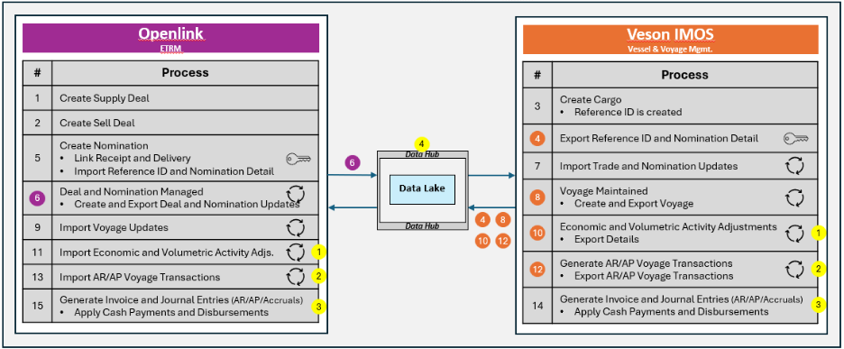
Figure 1: Accounts Payable process
Business Workflows:
- AP Invoice posted in Openlink:
  - Will generate an Invoice export message and send it to SAP, triggered upon Posting in Openlink.
    - Posting in Openlink locks the Invoice, preventing further updates
- Payment\Receipt Entered in SAP:
  - Will generate Openlink simple Payment message and send to Openlink
    - This will mark the Invoice as paid and update the Openlink Payables\Receivables summary, along with Cash In\Out column on the Voyage Profit and Loss view.

